Bacani, Micah Angelo R. 2018 – 01602

Activity 5

1. 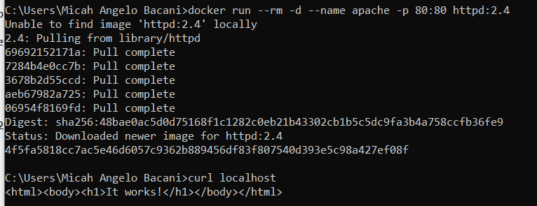Setting up httpd
2. 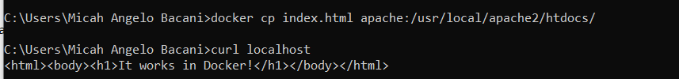It works in docker!
3. Possible data problems

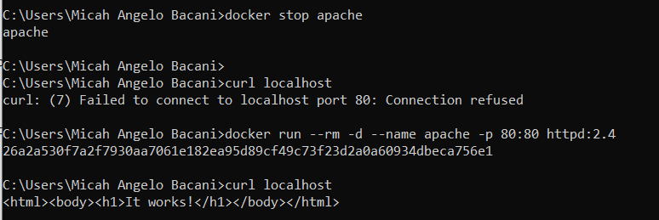

1. 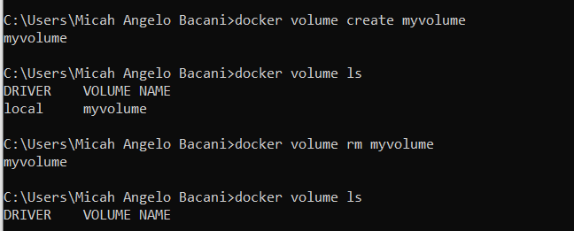Create and remove volume
2. Volumes in action

